Name:…………………………………………………………Index No.:……………….

Signature: ………………………………………………

545/1
CHEMISTRY
PAPER 1
JUNE, 2018
1 ½ HOURS GAYAZA HIGH SCHOOL

Uganda Certificate of Education
CHEMISTRY
PAPER 1
TIME:1hour 30minutes

Instructions:
- This paper consists of 50 objective type questions.
- Attempt all questions.
- Write the most correct alternative with either a blue or black ink-but not a pencil.

1. The diagram below shows the appearance of a wooden splint after it was placed across a Bunsen Burner flame.

Wooden splint

Charred part

What do the charred parts indicate about the flame? The flame is;
A) Non-luminous B) luminous

C) not uniformly hot D) middle zone is cool

2. The presence of impurities in a liquid
A) lowers the boiling point of the liquid

B) increases the boiling point of the liquid
C) has no effect on the boiling pint of the liquid
D) makes the liquid boil gently
3. Which one of the following is an alloy of zinc?
A) duralumin B) steel

C) solder D) brass

4. The percentage of water of crystallization in FeSO₄.7H₂O crystals is
(Fe=56, O=16, S=32, H=1)
A) 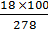 B)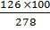

C) 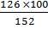 D) 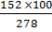

5. Which one of the following method will decompose lead (II) bromide to its elements?

A) electrolysis of an aqueous lead(II) bromide solution
B) elertoclysis of molten lead(II) bromide
C) bubbling chlorine gas into an aqueous solution of lead (II) bromide
D) reacting magnesium metal with an aqueous solution of lead(II) bromide

6. Which equation represents the reaction that takes place at the anode when a 2M potassium iodide solution is electrolyzed using carbon electrode?
A) 2H⁺_{(aq)} ⁺ + 2e H_{2(g)}

B) K⁺_{(aq)} + e K_{(s)}
C) 2I⁻_{(aq)} I_{2(aq)} +2e
D) 4OH⁻_{(aq)} 2H₂O_{(I)} + O_{2(g)} + 4e
7. The elements R reacts with the element T of form a compound R3T2. The ion formed by T is;

A) T²⁺ B) T³⁺ C) T³⁻ D) T²⁻

8. 20cm³ of hydrochloric acid of unknown molarity reacted with 25cm³ of 0.05M sodium carbonate solution. The molarity of the acid is;
A) 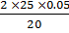 B) 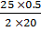

C) 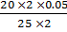 D) 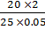

9. Sodium carbonate dissolves in water as shown by the ionic equation
(aq)

The pH of the solution
A) 1 B) 6 C) 7 D) 9

10. The gas collected when chlorine water is exposed to sun light is;
A) chlorine B) oxygen

C) hydrogen chloride D) hydrogen

11. Which one of the following salts is formed when sulphur dioxide is passed through sodium hydroxide solution for a long time?

A) sodium sulphate B) sodium sulphite
C) sodium hydrogen sulphate D) sodium hydrogen sulphite

12. The atomic number of chlorine is 17 and its mass number is 35. Which one of the following represent the chloride ion, Cl⁻
 | Protons | Neutrons | Electrons
A) | 17 | 18 | 17
B) | 17 | 18 | 16
C) | 17 | 18 | 18
D) | 18 | 18 | 17

13. Which one of the following is NOT a property of ethene?

A) it turns potassium manganate (VII) colourless
B) it is an unsaturated hydrocarbon
C) it is a saturated hydrocarbon
D) it decomposes bromine water

14. Which one of the following sulphides is soluble in water?
A) sodium sulphide B) calcium sulphide
C) iron(II) sulphide D) lead (II) sulphide

15. Which of the following cations will NOT form a carbonate when reacted with sodium carbonate/

A) Al³⁺_{(aq)} B) Fe²⁺_{(aq)}
C) Ca²⁺_{(aq)} D) Mg²⁺_{(aq)}

16. 2.02g of potassium nitrate was heated strongly. What volume of oxygen measured at room temperature was evolved?
2KNO_{3(s)} 2KNO_{2(s)} + O_{2(g)}
(Molar volume of gas at 25⁰C = 24dm³, K=39, N=14, O=16)

- 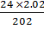 B) 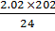
- 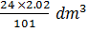 D) 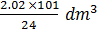

17. A gas that formed white fumes with ammonia and reacted with potassium iodide solution to form a reddish brown solution is;

A) hydrogen B) sulphur dioxide
C) chlorine D) hydrogen chloride

18. Which one of the following salts is best prepared by the action of dilute sulphuric acid on the metal?

A) CaSO₄ B) MgSO₄
C) CuSO₄ D) PbSO₄

19. The following experiment was set up to investigate movement of ions through an electrolyte during electrolysis.
A
B
Connecting wires
Connecting wires
Switch
Wet filter paper soaked in KNO₃
Copper (II) sulphate crystal

Which one of the following was observed?

A) Blue colour moved towards electrode B
B) blue colour moved towards electrode A
C) a brown deposit moved towards electrode B
D) bubbles of a colourless gas moved toward electrode A

20. Milk is a fine heterogenous mixture of water, fat and lactic acid. The components of milk are best separated using;

A) separate funnel B) filtration
C) decantation D) centrifugation

21. Which one of the substances underlined in the equations below is being reduced?
A) CuO_{(s)} + H_{2(g)} Cu_{(s)} + H₂O_{(l)}

B) 2NH_{3(g)} + 3CuO_{(s)} 3Cu_{(s)} + 3H₂O_{(l)} + N_{2(g)}
C) 2SO_{2(g)} + O_{2(g)} 2SO_{3(g)}
D) H₂S_{(g)} + Cl_{2(g)} S_{(s)} + HCl_{(g)}

22. Which one of the following substance does not liberate chlorine gas when reacted with concentrated hydrochloric acid under suitable conditions?

A) manganese (IV) oxide B) lead(IV) oxide
C) manganese (II) oxide D) potassium manganate (VII)

23. Solid carbon dioxide, ‘dry ice’ is used as a refrigerant because it
A) vaporizes B) sublimes

C) condenses D) melts

24. The solubility curve of salt A is shown below

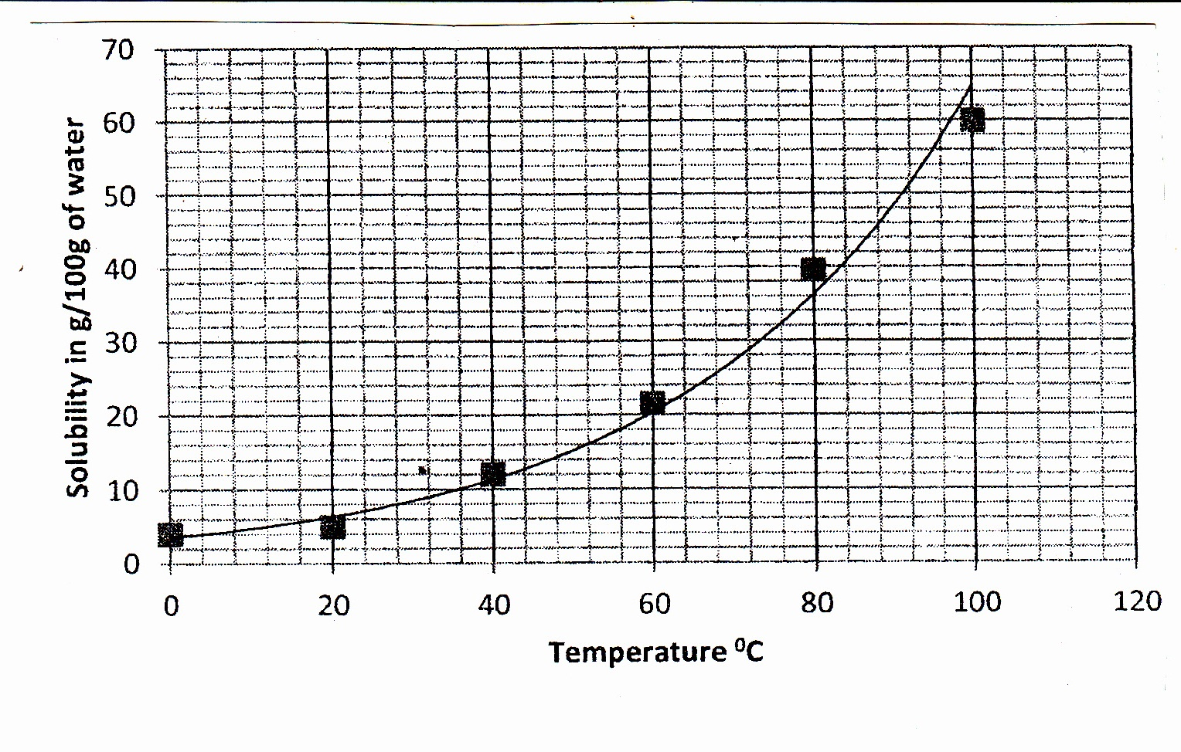
The mass of salt A which dissolves in 25g of water at 52⁰C is;

A) 64g B) 4g
C) 16g D) 12g

25. Which of the following substances does not conducted electricity at room temperature?

A) graphite B) mercury
C) lead D) sodium chloride

26. A colourless gas that turns potassium manganate (VII) from purple to colourless and has no effect on moist litmus paper is;

A) sulphur dioxde B) hydrogen sulphide
C) ethane D) ethene

27. Atoms of elements in the same period in the periodic Table
A) occupy the same number of energy levels

B) have the same number of electrons in the outermost energy level
C) have the same atomic radius
D) have the same chemical properties
28. The electronic configuration of an atom of is;

A) 2:8:1 B) 2:3 C) 2:8:6 D) 2:4

29. Anhydrous iron(II) chloride is best prepared when;
A) dry chlorine is passed over heated iron

B) dry chlorine gas is passed over heated iron(II) oxide
C) dry hydrogen chlorine gas is passed over heated iron
D) dry hydrogen chlorine gas is passed over heated iron(II) oxide

30. A certain hydrocarbon has 82.2% by mass carbon. Its molecular mass is 58. Its empirical formula is? (C=12, H=1)

A) C₂H₂ B) C₂H₅
C) C₂H₈ D) C₄H₁₀

31. Which one of the following reactions is not a displacement reaction?
A) H₂SO_{4(aq)} + KNO_{3(s)} KHSO_{4(s)} + HNO_{3(l)}
B) 2NH₄Cl_{(s)} + Ca(OH)_{2(s)} CaCl_{2(aq)} + 2NH_{3(g)} +2H₂O_{(l)}

C) H₂SO_{4(aq)} + Zn_{(s)} ZnSO4(aq) + H_{2(g)}
D) ZnO_{(s)} + H₂SO_{4(aq)} ZnSO_{4(aq)} + 2H₂O_{(l)}

32. Ammonia gas decomposes into hydrogen gas and nitrogen gas according to the equation:
2NH_{3(g)} 3H_{2(g)} + N_{2(g)}

The volume of hydrogen formed when 40cm³ of ammonia decomposes is;
A) 20cm³ B) 40cm³

C) 60cm³ D) 26.7cm³

33. How many chloride ions surround each sodium ion in the sodium chloride crystal?

A) 4 B) 6
C) 8 D) 10

34. When magnesium ribbons heated strongly in air, a mixture of;
A) magnesium oxide and magnesium peroxide is formed

B) magnesium oxide and magnesium nitride is formed
C) magnesium oxide and magnesium carbide is formed
D) magnesium oxide and magnesium hydride is formed
35. Elements X, Y and Z have atomic number 12, 8 and 7 respectively. Which one of the following compounds is ionic?

A) XY B) Y₃Z₂
C) X₂Z D) Y₂Z₃

36. The particles of matter which combines in a definite proportion in a chemical reaction are the;
A) atoms B) molecules

C) electrons D) protons

37. The formation of acid rains is due to the following gases that are released into the atmosphere except;
A) Cl₂ B) SO₃

C) NO D) CO₂

38. Stalagmites and stalactites are formed according to the following equation
A) CaCO_{3(s)} CaO_{(s)} + CO_{2(g)}

B Ca(HCO₃)_{2(aq)} CaCO_{3(s)} + CO_{2(s)} + H₂O_{(l)}
- Ca(HSO₄)_{2(aq)} CaSO_{4(s)} + SO_{2(s)} + H₂O_{(l)}
- CaSO_{4(aq)} CaO_{(s)} + SO_{3(g)}

39. Which of the following methods is used to prepare an aqueous solution for ammonia?
Ammonia
A) B)

Ammonia

Ammonia

C) D)
Ammonia

Water

40. When a candle burns in air, the product of combustion turns lime water and milky white anhydrous copper(II) sulphate blue. The best conclusion from this experiment is;
A) carbon dioxide and water are give off

B) a candle is a compound of carbon dioxide and water
C) a candle is a mixture of carbon dioxide and water
D) a candle is a compound of carbon and hydrogen

In each of the following 41 to 45, one or more of the answers given may be correct. Read each question carefully and then indicate the correct answer according to the following;
A. If 1, 2, 3 only are correct B. If 1, 3 only are correct
C. If 2, 4 only are correct D. If 4 only is correct

SUMMARY OF INSTRUCTIONS;
A | B | C | D
1, 2, 3 | 1,3 | 2,4 | 4
Only correct | Only correct | Only correct | Only correct

41. Sodium chloride conducts electricity in the molten state because
1. the electrostatics forces of attraction are broken down

2. the electrostatics forces of attraction are weakened
3. it contains mobile electrons
4. it contains mobile ions

42. Which of the following solutions contains the same number of hydrogen ions?
1. 1dm³ of 1M H₂SO₄ 2. 1dm³ of 2M HCl

3. 2dm³ of 1M HNO₃ 4. 1dm³ of 1M CH₃COOH

43. Which of the following method(s) remove temporary hard water only?
1. addition of sodium carbonate
2. distillation

3. ion exchange
4. addition of calcium hydroxide

44. Which one of the following salt dissolves in water to give an alkaline solution?

1. Na₂CO₃ 2. NaCl
3. CH₃COONa 4. NH₄Cl

45. Which of the following elements forms more than one oxide?
1. nitrogen 2. Sodium

3. carbon 4. Calcium

Each of the questions 46-50 consists of an assertion (statement) on the left-hand side and a reason on the right-hand side.
A. If both the assertion and reason are true statements and the reason is a correct explanation of the assertion.
B. If both the assertion and reason are true statements but the reason is not a correct explanation of the assertion.
C. If the assertion is true but the reason is not a correct statement.
D. If the assertion is incorrect but the reason is a true statement.

SUMMARY OF INSTRUCTIONS
Assertion | Reason
A. True | True (reason is a correct explanation)
B. True | True (reason is not a correct explanation)
C. True | Incorrect
D. Incorrect | True

46. Hydrogen gas is collected hydrogen is less dense
by downward displacement because than air.

of air.

47. When magnesium (IV) Maganese(IV) oxide
oxide is added to hydrogen because decomposes to form
peroxide solution, rapid more oxygen.

effervescence occurs.

48. Carbon dioxide forms carbon dioxide is an
a white precipitate when because acidic anhydride.

reacted with calcium
hydroxide.

49. Sodium hydrogen sodium hydrogen

carbonate solution because carbonate is an acid
turns blue litmus red salt.

50. Concentrated sulphuric sulphuric acid is a

acid chars sugar crystals because strong acid.

**END **

